**Running the server program**

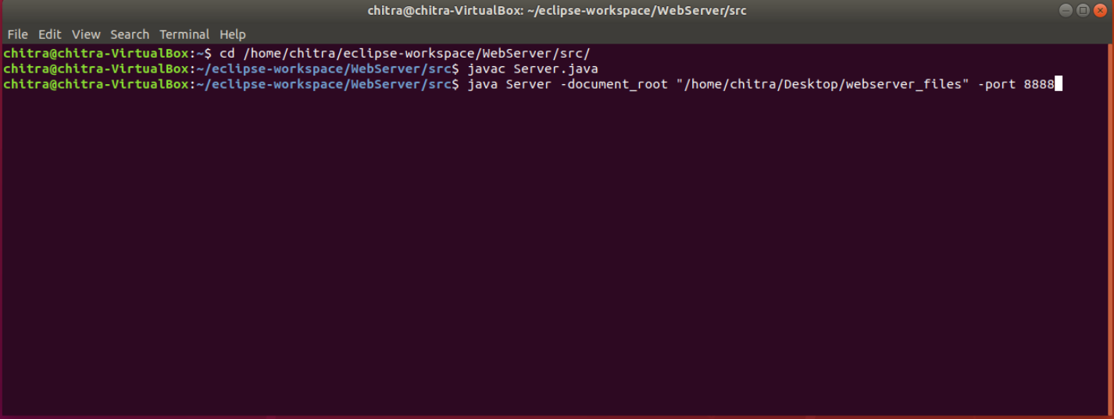

**Screenshots of output**

1. **Status Code : 200 OK - When the request is valid, requested file is available and the files has access permissions**

**Input :** localhost:8888



**Input :** localhost:8888/index.html



1. **Status Code : 403 Forbidden When the requested file exists but doesn’t have read permissions.**

Changing the access permission of index.html file to deny read access using chmod command.

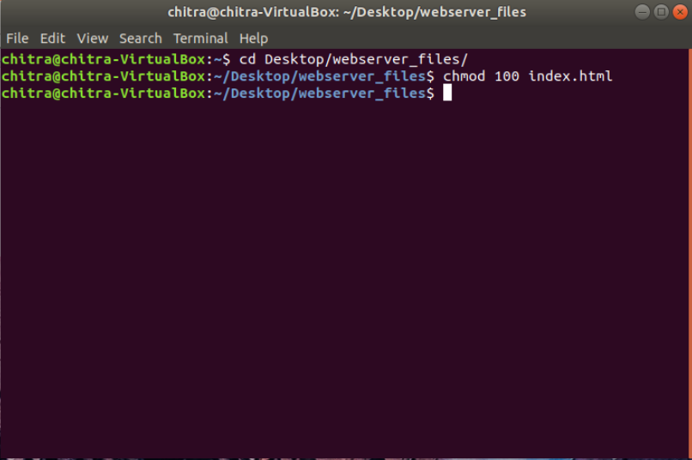

**Input :** localhost:8888/index.html

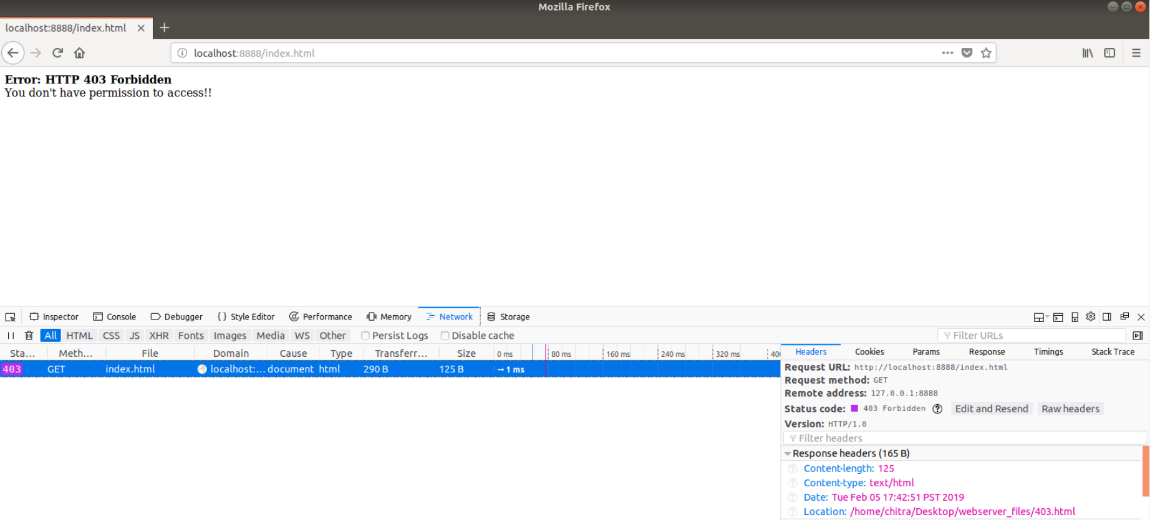

1. **Status Code: 404 Not Found If the requested file is not available in the server directory**

**Input:** localhost:8888/cat.html

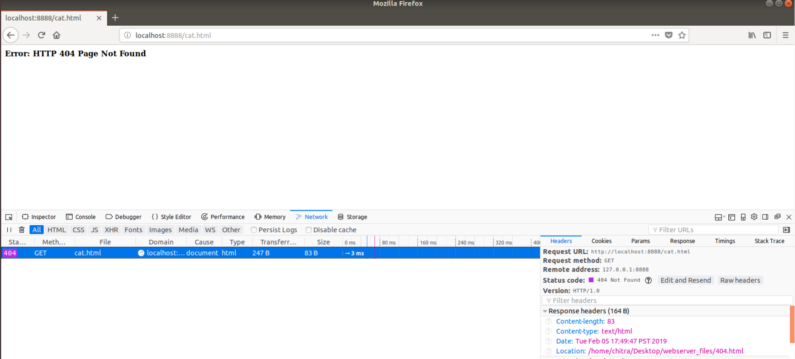

1. **Status Code: 501 Not Implemented HTTP request methods other than GET**

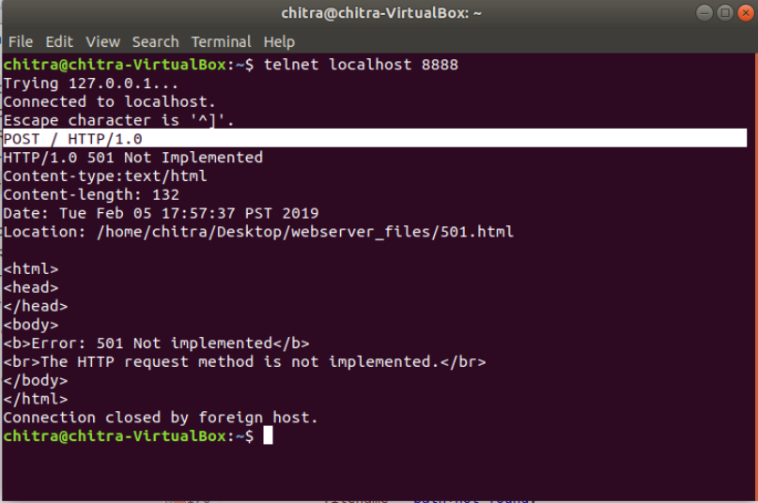

1. **Status Code: 505 HTTP Version Not supported HTTP versions other than 1.0/1.1 are not supported**

**Input HTTP Request :** GET / HTTP/2.0

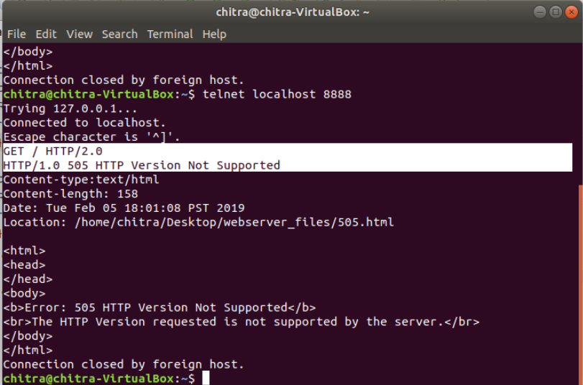

1. **Status Code: 400 Bad Request Requests that are not in the format (HTTPMethod Filename HTTPVersion)**

**Input HTTP Request :** GET /

